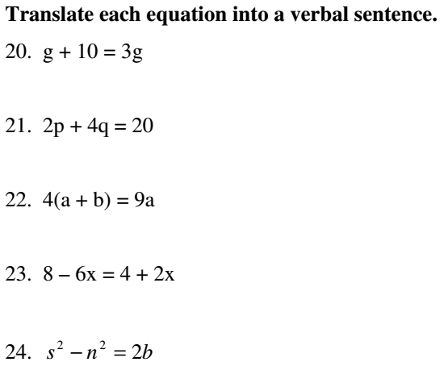
Directions: Read the word sentence and write its equivalent number sentence.
Phrase or word Sentence | Equivalent Number Sentence
- two decreased by a number
- a number decreased by two
- two less than a number
- four more than a number
- the difference between 6 and a number
- subtract four from a number
- the sum of 4 and a number
- the opposite of the sum of a number and three

