Week 1: Everything in geometry begins from a point! Points make lines. Lines become rays with end points and direction. Two rays that share an endpoint make an angle. If the endpoint of an angle is the center point of a circle, certain properties can be identified.

Artifact #1- Geometry in the Plane
Part 1: Points make lines, lines make rays, rays make angles, | Part 2: Center point and its distance to the edge of the circle  All parts are equal- and angles inscribed in a circle are Predictable. | Part 3 Developing an understanding of circle properties and area.
Q: Is there a relationship between an angle and a fraction? | Q: How can we use the relationship we discovered between angles and fractions to find the measure of an inscribed angle’s arc. 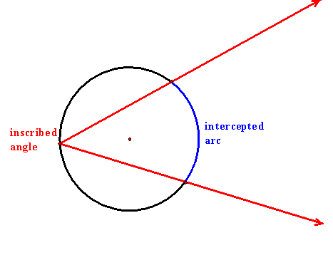 | Q. Is there a relationship between a rectangle and a circle?  Q. How can an understanding of a rectangle be used to find the space inside a circle?

Week 2: The distance from the center point of a circle to the circles edge is the radius of a circle.
The circumference is the distance around a circle.
The diameter is the distance across the circle. Application of these terms can help develop understanding of circle properties; and calculations for the area of the circle.
https://www.youtube.com/watch?v=rFY3Joeit6M
http://jwilson.coe.uga.edu/emt668/EMAT6680.2003.fall/Nichols/6690/Webpage/Day%204.htm

