Do Now 3/11/16-1st hour
- Analyze the table from Mr. Miller’s class. If you graphed the points, what kind of line would it produce (sloped, vertical, horizontal)? Write the equation of the line (based on the table). What would be the unit rate of the ratio in this table for the money raised in the given amount of time.
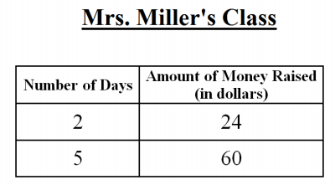

- Does the graph represent a proportional relationship? (Explain why or Why not). Write the equation of this line. What method did you use to find the slope?

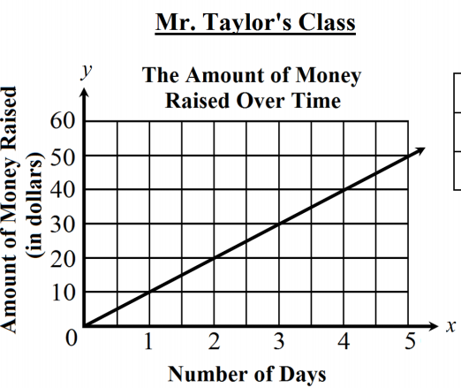

- Comparing Mr. Miller and Mr. Taylor’s classes; which class would have raised the most money in one day? (explain how you found your answer.

