Do Now 5/23/16
Directions: You must determine if the equations listed below ARE “systems”. You must explain your determination by telling which method you used and show your application of the method.

1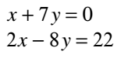 2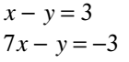 3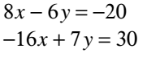

You may use this graph or graph paper.
