Do Now 6-7-16

Determine which of the three methods for finding asolution is best. State your method and explain your reasoning for choosing the method. Show your work! You will be graded on the method you choose and the accuracy of your solution.

2. 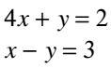
1.