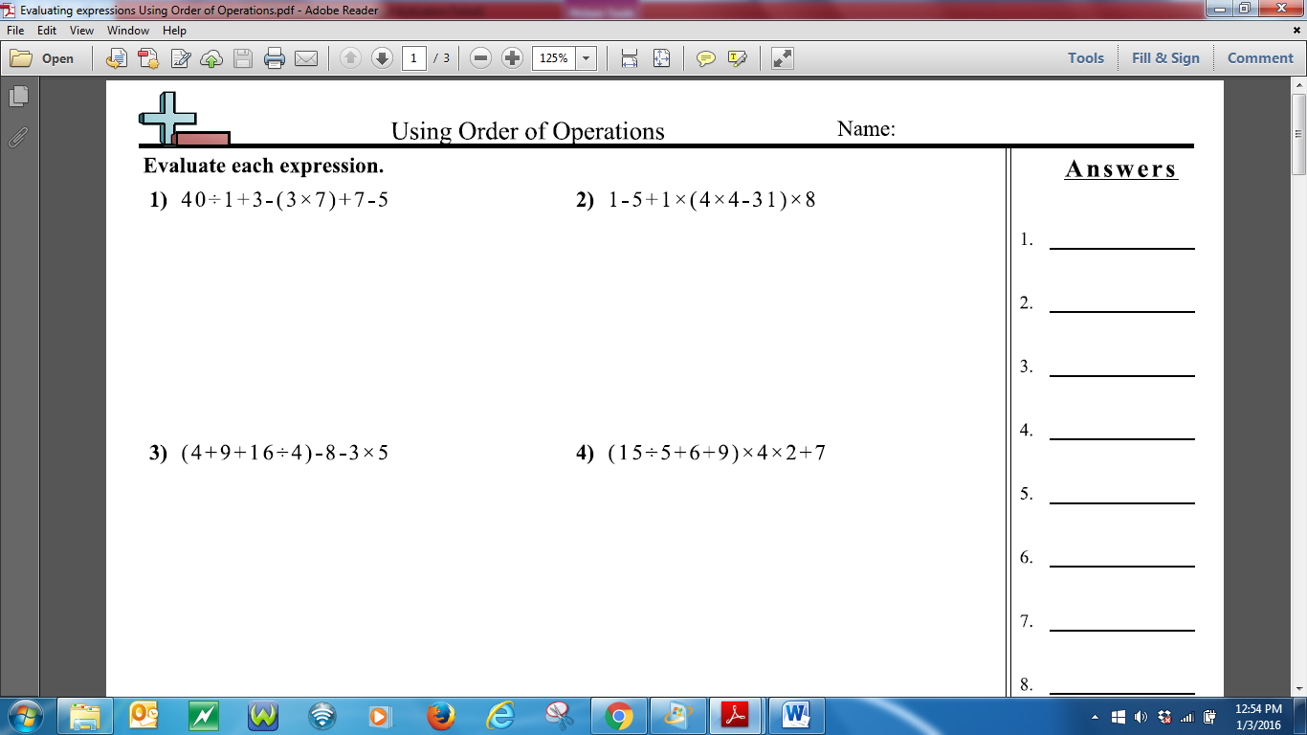

**Name:** ______________________________________________________

