Today’s Do now is a “Pair-Share” assignment, designed to review the proofs of exponents. Before we watch the video, try to complete as many of the boxes as you can with the correct information. If you are not sure, put a check mark next to it and move on. The pair will have 5 minutes to complete what you know BEFORE we watch the video. After the video, the CLASS will discuss the misconceptions or understandings. The pair of you will have the next 20 mins to complete the assignment with the CORRECT information.
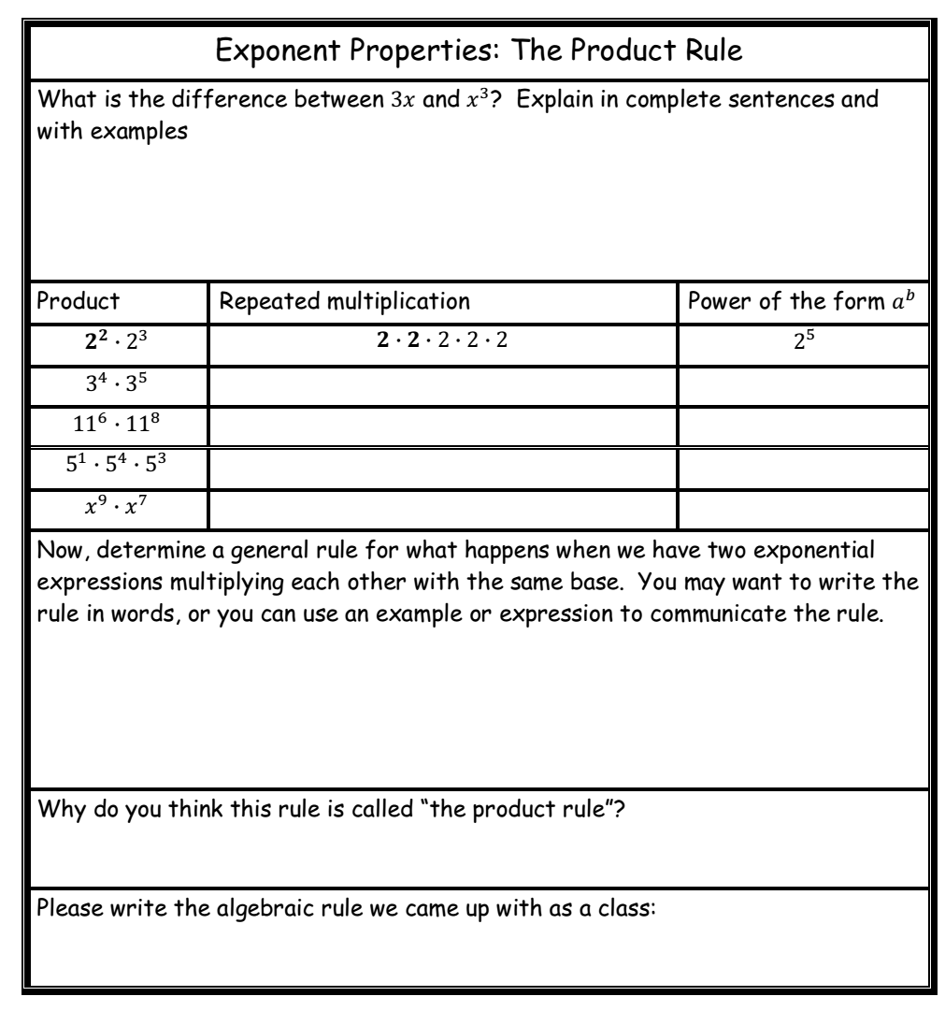

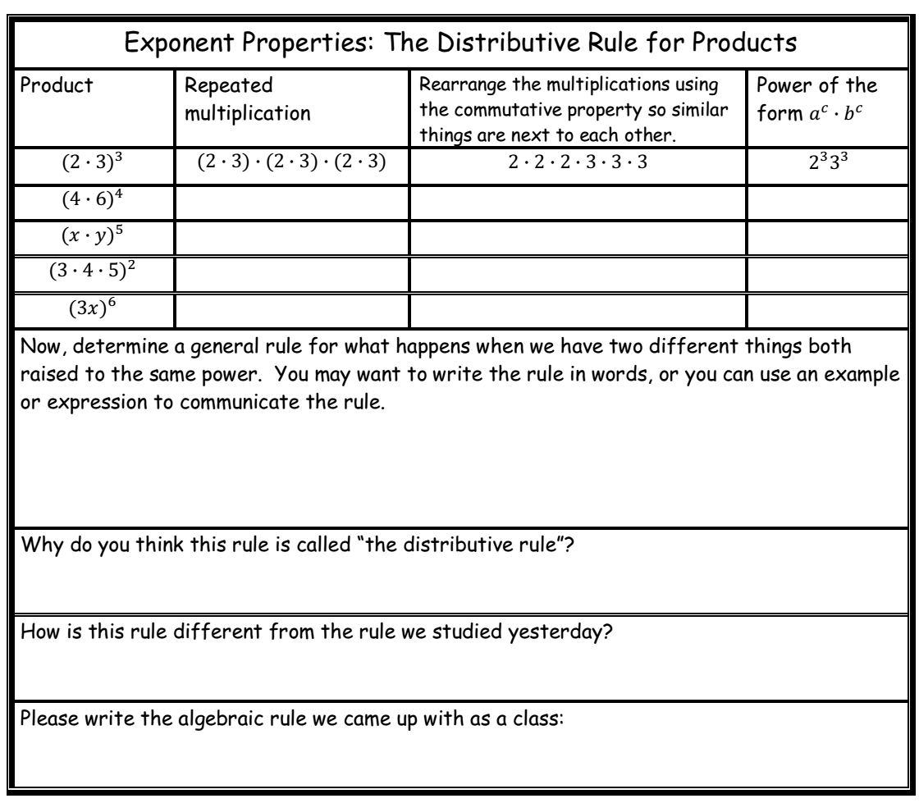

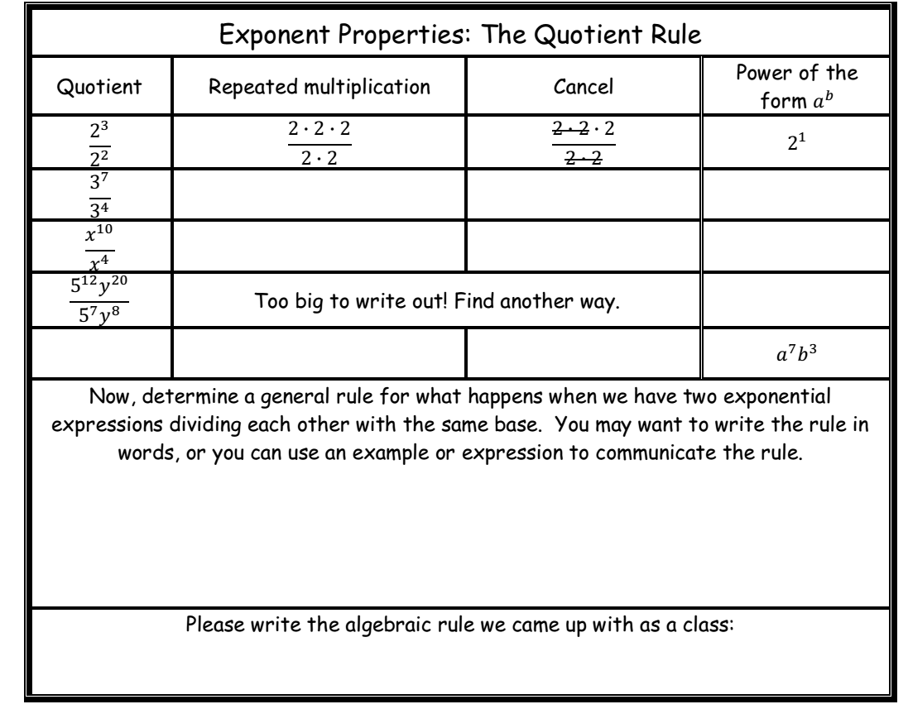
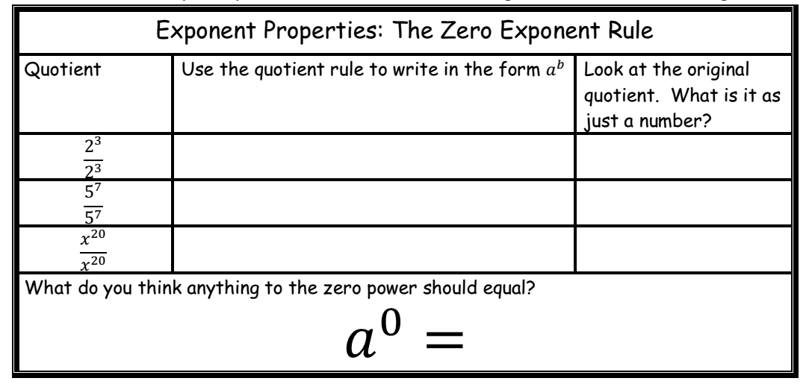
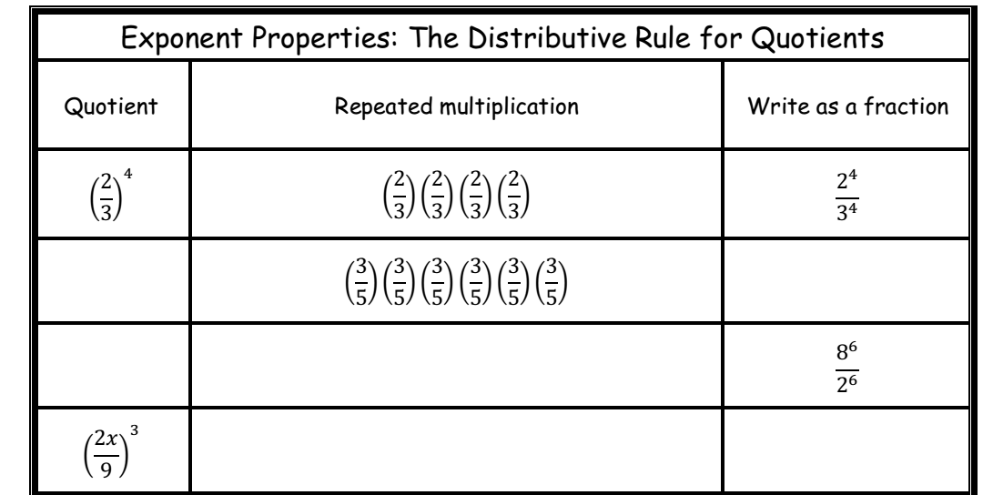

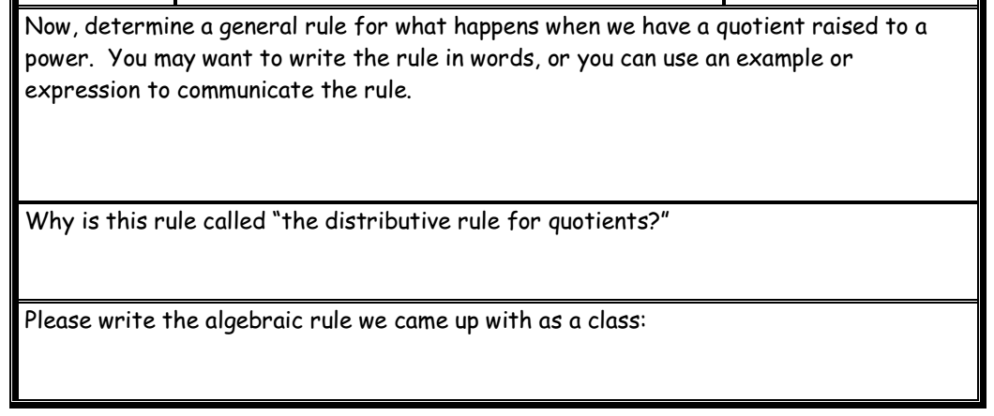
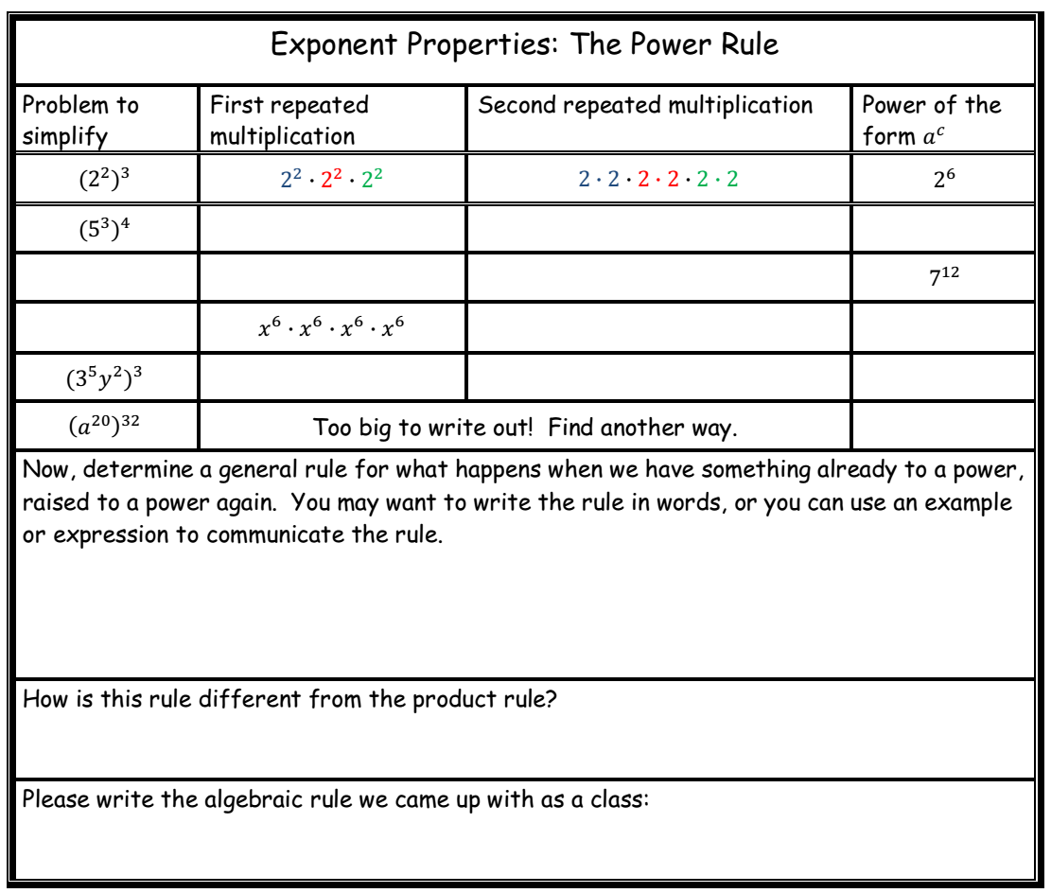

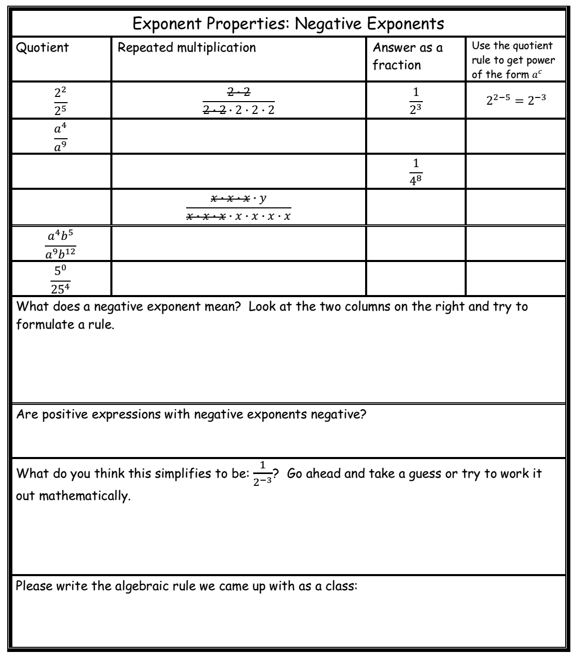

Video reference: https://www.youtube.com/watch?v=KFm1rup4hkI

