NAME:

DATE:

CLASS PERIOD:

**Directions**

1. Use the protractor to make two rays who share an endpoint (within the circle). Be sure to draw each ray a different color. Extend the end of rays until they intercept the circle.

2. Find the degree of “open-ness” of the angle by measuring the arc. Be sure to use a different color for the intercepted arc.

**Geometry in the plane: INSCRIBED ANGLE AND ITS’ PROPERTIES.**

PUT YOUR EXPRESSION IN THE TRIANGLE

Develop a general mathematical rule that can be used to find the measure of an angle’s arc, WITHOUT USING A PROTRACTOR…

Advanced thinker portion

Hint: How many equal parts in the whole pie?

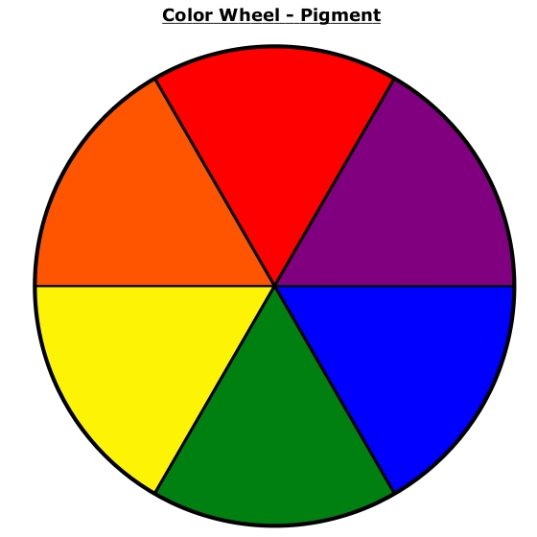

Define a fraction.

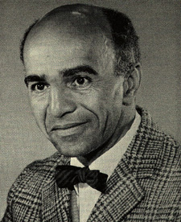

Exit Ticket Question: What does an inscribed angle have to do with a fraction?

________________________________________________________________________________________________________________________________________________________________________________________________________________________________________________________________________________________________________________________________

Directions: Use the space below to reply to the exit ticket question. PRINT you response using PENCIL only.