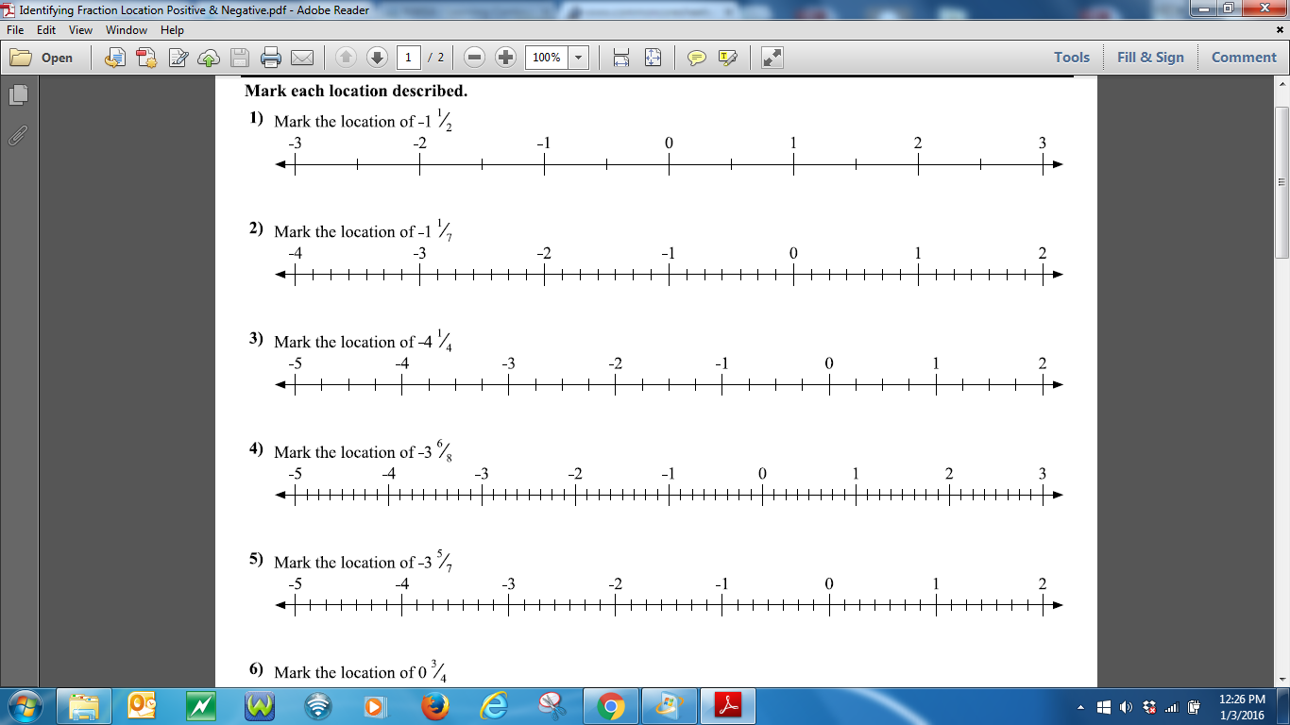

**Name:__________________________________________**

**Date:____________ Station #3 Identifying Rational numbers on the number line Directions: After marking the locations, subtract each location from 10.00. Show your work. Circle your answer.**

