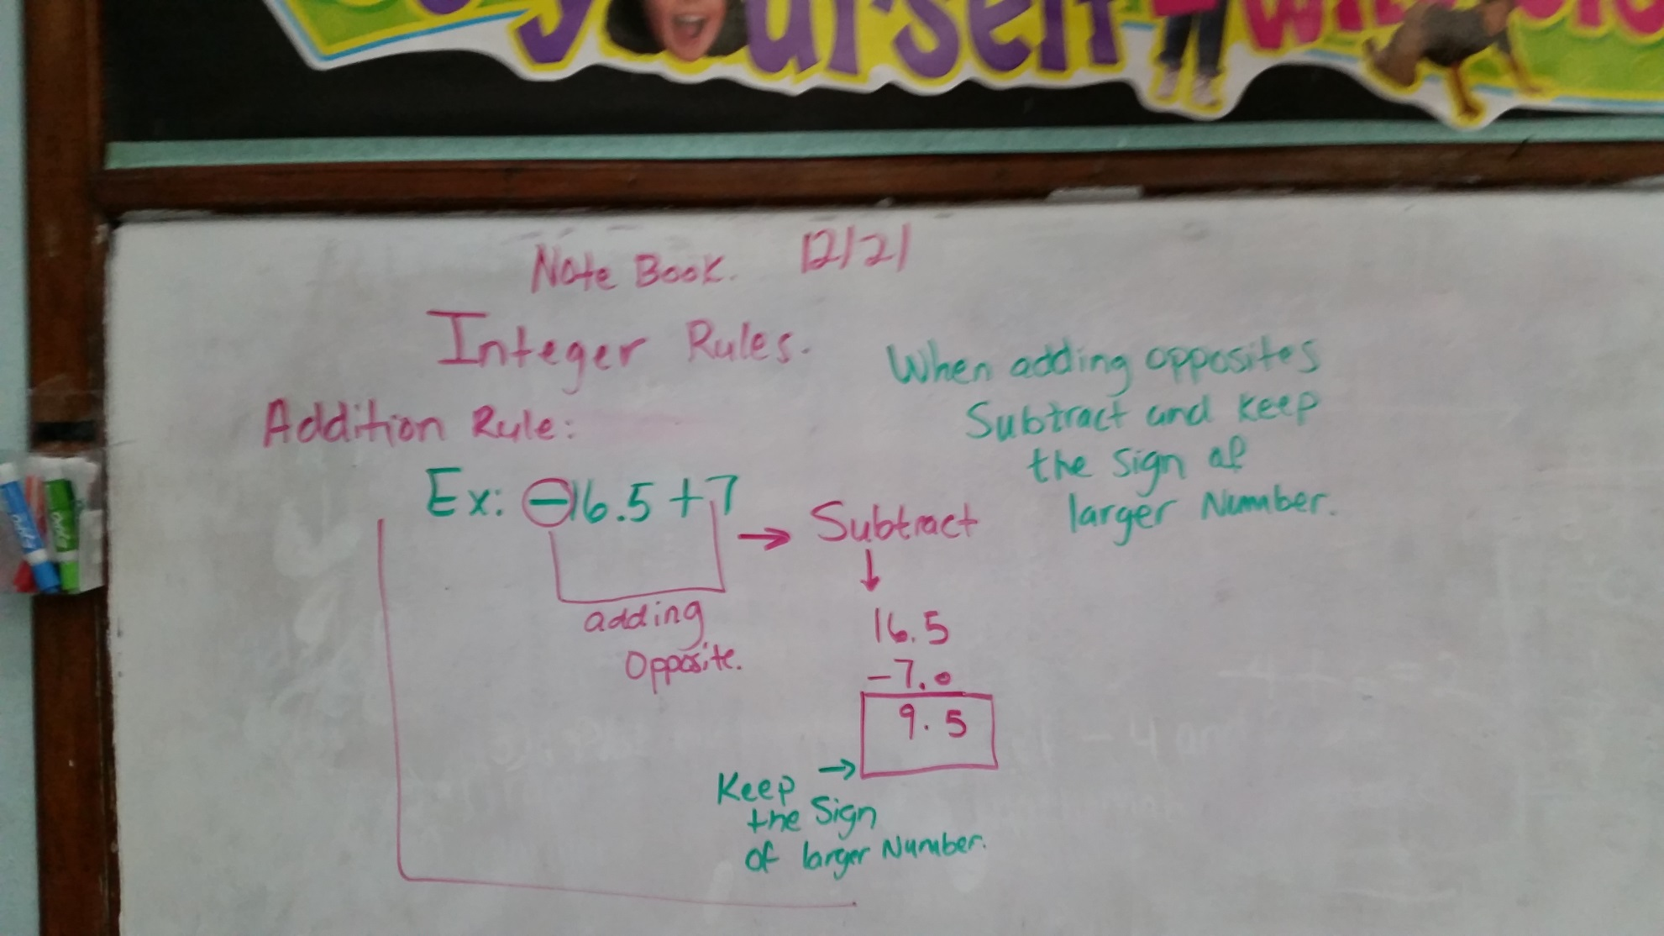

**Inequalities:**

**a≥b- “a” is greater than or equal to b**

**a˃b “a” is greater than b**

**a<b “a” is less than b**

**a≤b “a” is less than or equal to b**

**a≈b “a” is approximately b**