Making connections:
You are going to make a connection between rational numbers and their decimal equivalence using a numberline and long division.
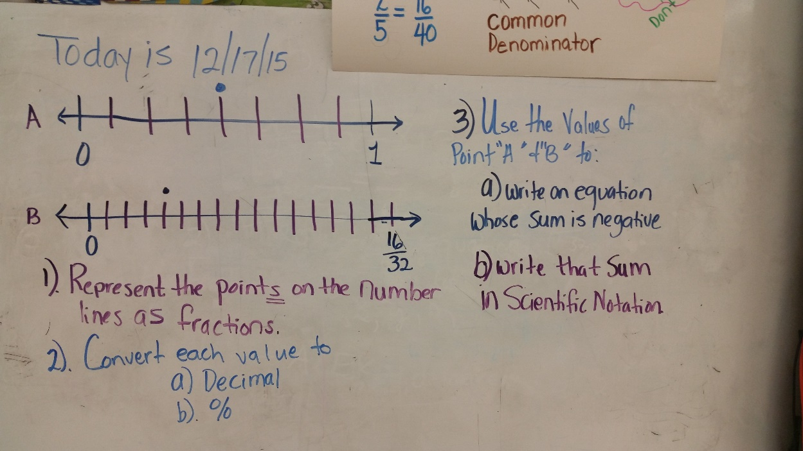
DIRECTIONS
1. Number line A: What "Kind" of number is represented by this number line? Choose your answer and justify (explain how you know your choice is right) why you chose it.
- Whole Number
- Counting Number
- Integer
- Rational Number
- Irrational Number
2. Write the fraction representation for the points listed in number lines, A&B; and explain why you chose the numerator and denominator you chose.
3. Convert the fractions that you wrote for number 2 into their decimal equivalences and use your understanding of place value to justify your decimal equivalent.

Directions: You must WRITE a justification for the answer given on question#3. Your explanation MUST include any of the properties and rules(operations of signed numbers rules) that were used to reach the negative sum. Your work will be graded on the use of math terminology and your selection from each of the boxes listed below. (I am not an English teacher, I will not grade on spelling or grammar, I want to undestand what you are thinking…
Question #3 asks you to use the values from number lines A and B to write an equation whose sum is negative. This is the answer (-1) ($\frac{4}{8}$) + $\frac{4}{32}$= -$\frac{12}{32}$.
Adding opposites: Subtract and keep the sign of the larger number.
Subtracting: Add the opposite sign.
Adding or subtracting the same sign: Do the math and keep the signs.
Multiplying opposites: The product is negative
Dividing opposites: The quotient is negative
Multiplying or dividing the same sign: Product or quotient is ALWAYS positive
Associative property of addition
Associative property of multiplication
Commutative Property of addition
Commutative Property of multiplication
Distributive Property
Multiplicative Identity
Additive inverse property
Multiplicative inverse property

