Directions: Use the Examples to help you complete this station. Print when ever necessary.
STATION #5
Part 2
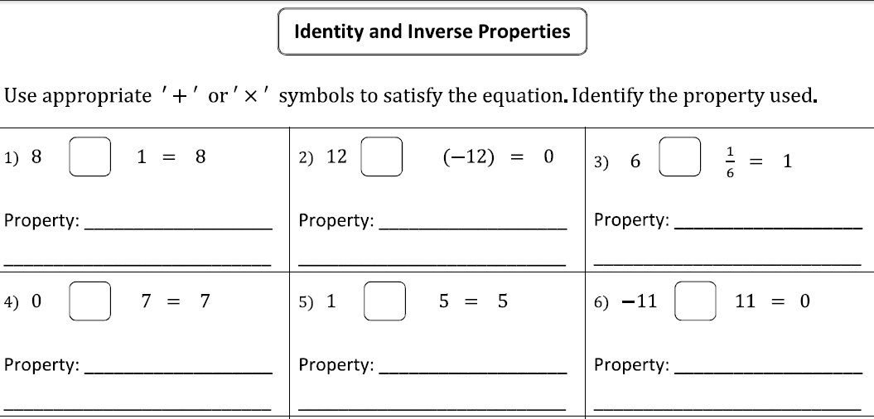
Part 3: Show your work on a separate Sheet. Be sure to number correctly and WRITE YOUR NAME.
Part 4: Find “X” to balance the equation and write the property.

