Review Station directions:
The website is saved on the computer, YOU ARE NOT TO GO TO ANY OTHER WEBSITES.
If the site is missing: http://www.classzone.com/cz/books/msmath_1_na/book_home.htm?state=MI copy and paste.
When you are on the correct website, you will see this:
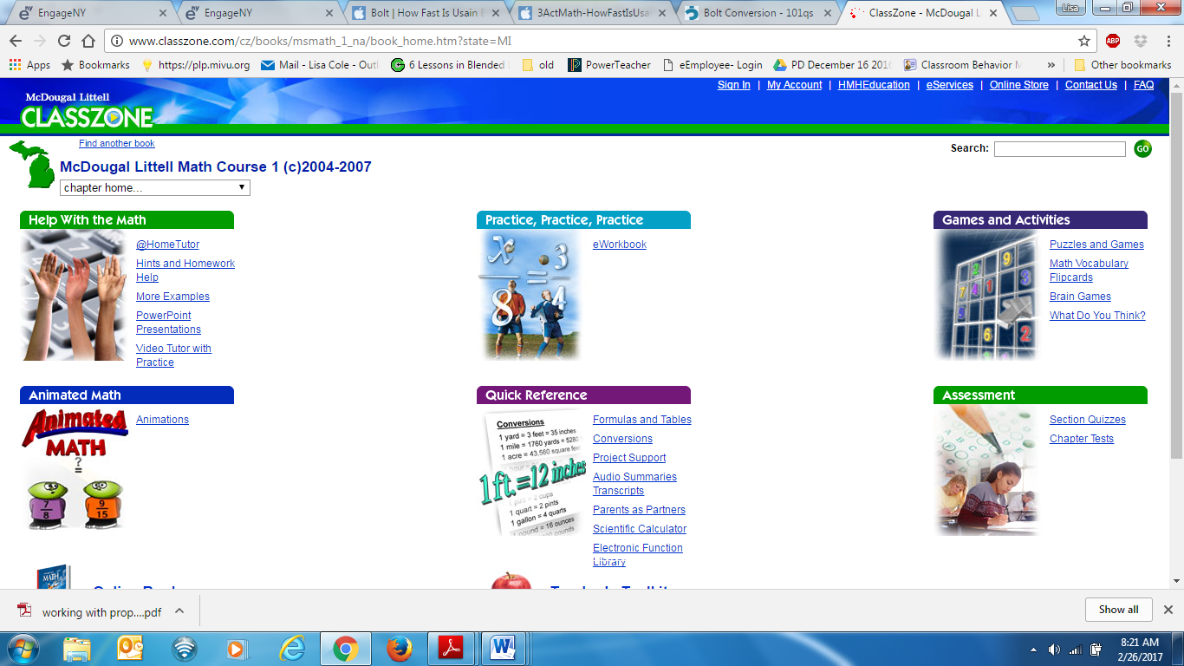
When you have finished answering ALL of the questions, you will choose “CHECK ANSWERS”. SAVE THE RESULTS on your desk top with your name. Open your email and send your results to me as an ATTACHMENT! My email: lcole@eaaofmichigan.org. Or you can send it through your ALEKs login.
TABLE LOG
Get started: Choose the eWorkbook link
YOUR name & DATE | # & title of Review Chapter | # of the lesson you are reviewing

