Unit rate & Constant of proportionality
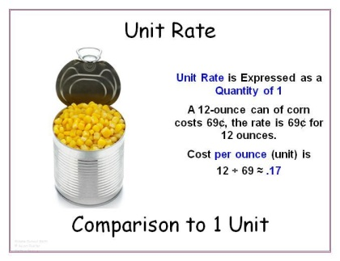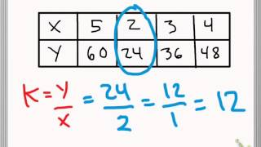
Directions: Use this link to watch the video- https://www.youtube.com/watch?v=KvBMuB4FeWE Before you begin to answer the questions, WATCH THE WHOLE VIDEO!

Question #1
How did he use the “slope” to determine which of the objects was traveling the fastest?

Question #2
Do the tables/graphs represent proportional realtionships? Explain why or why not.

#3Application:
You must write two equations based on the objects that you saw in the video.
Object letter____ Equation:
Object letter____ Equation:

