What you need to remember about REFLECTIONS: TRANSFORMING the mirror image.

What is Reflection?
In a reflection transformation, all the points of an object are reflected or flipped on a line called the axis of reflection or line of reflection. In Geometry, a reflection is an isometry, which means the original and image are congruent, that can be described as a "flip". To perform a geometry reflection, a line of reflection is needed; the resulting orientation of the two figures are opposite.
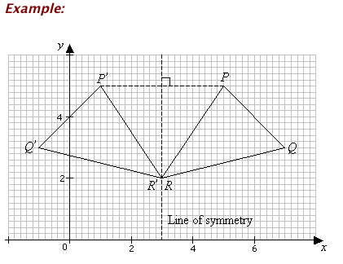
A reflection is defined by the axis of symmetry or mirror line. In the above diagram, the mirror line is x = 3. The line of reflection is the perpendicular bisector of the line joining any point and its image (e.g. PP ’ in the above figure).

Drawing The Image on Grid Lines
If the axis of reflection is on one of the grid lines, we just count the number of squares from a point on the object to the axis and the image is the same distance from the axis.
Example:
In the diagram, the figure A is reflected in the line XY. Draw the image of A in the diagram.
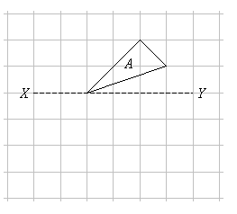

Reflection on the Coordinate Plane
Note the patterns of the coordinates when the points are reflected over different lines of reflection.
Coordinate Rules for Reflection
If (a, b) is reflected on the x-axis, its image is the point (a, -b)
If (a, b) is reflected on the y-axis, its image is the point (-a, b)
If (a, b) is reflected on the line y = x, its image is the point (b, a)
If (a, b) is reflected on the line y = -x, its image is the point (-b, a)

Memory NOTE: Remember when we were characterizing Lines? Proportional lines slope (look diagonal) WHEN Y= X , horizontal lines when “Y” (of the ordered pair) remains constant)), and Vertical Lines, when “X” (of the ordered pair) remains constant. This is the information you will use to DRAW your lines of reflection.

WHEN Y=3, your reflection line will run HORIZONTAL
WHEN X=3 your reflection line will run VERTICAL

WHEN Y=X- Your reflection line will be a slope DIAGONAL, use the coordinates of the first plot, to switch the (X,Y) for the reflection plot.

